
DARTECH AND WILMINGTONIAN
A NEWSLETTER FROM YOUR OLD SCHOOL

NUMBER 19 MARCH 2005

Colin Tedman - 1969-1976
Firstly I wish to thank you and all the people involved in the Dartech and Wilmingtonian Association for the recent newsletters. I had no idea that said association was in existence until I visited the school on the off chance in 2002 and bumped into my French teacher Graham Nicholls who was filling in as part time gardener outside the office! We had quite a chat and I left having information on the old-boys in my hot little hands. I never realised that I had missed some (then) nine years of newsletters and therefore info on former classmates. I have kept contact with 3 regularly over the years Neil Hall Keith Watson Michael Todd and through the association Wade Nash and Bill Leavens partners in crime in the 6th form.
Reading former pupils stories has made me remember a lot of names and rekindled a lot of memories. It also highlights the post school affection which we hold for our teachers- I’m sure this grows as we appreciate what being a teacher means and we seem them as human beings rather than as simply that teachers during our school lives.
I was at the school from 69-76 in the L forms and can still recite the register! I can remember waiting for the bus in Dartford town centre (how much that has changed since then) and having the option of the 401 from near the cinema or the 423 or the 477 from the bus stops near the park/museum did anyone ever visit that? The prefects all had blue ribbons around their blazers and to a 11 year old all looked like grown men! I read with great interest memories of Mr Lawson “Tutters” my form teacher in either the 4th or 5th year. Anyone late would get a booming OUTSIDE if they tried to enter after the bell and an essay would follow. Offenders in economics would receive the pile of atlas’s dropped onto the head or the board rubber treatment and be covered in chalk dust for the rest of the day. Tutters arranged a Norfolk Broads holiday in the lower 6th form I’m sure under the guise of an educational trip: all that went learnt more about the difference between light and bitter and brown ale I am sure! I was booked to go but a stay in Joyce Green hospital with acute appendicitis put paid to that trip. We did arrange a canal holiday the following year, 6 of us which involved skipping the last few days of the Easter term. All projects were finished and handed in but word of our departure slipped out the following week and Mr Hollingsworth was not impressed ringing our parents to inform them of our deceit! The parents all knew and had lent us their cars to get there! The next term the headmaster Mr Edgler officially carpeted us and increased our prefectly duties..Mr Gough our woodwork teacher I remember took me aside and enquired if we had a good time “Yes” I replied and with a wry smile said “good” and sauntered off. I must admit it was very rewarding when a teacher would stop being a teacher for a moment and suddenly become a friend.
I was appointed/elected Head Prefect and with it came a certain amount of notoriety. On a Thursday morning after assembly when Percy Black would say “Tedman has a notice” the school would greet this with a loud groan and Percy would be scanning the throng with his usual scowl trying to pick out the perpetrators. I remember a few years before when one prefect not sure if I can reveal his name but it was the name of Peter Pans arch enemy was hell bent, so the rumours went, on giving out his 100th detention. I remember receiving one for some trivial offence (of course..) So I can remember the distrust we had for them – some of them anyway. The lunchtime patrols up into the woods where the smokers would congregate or the walkway along the back so you could come down from the top and catch those slow enough to be still puffing away.
I think we could all remember anecdotes some may have already been told- the fishpond in the front of the school where Mr Adams the English teachers car, an old black vehicle came to rest, I believe the football team received the blame. The same pond I believe had a pike caught from Ellinghams lakes deposited in there not sure what the resident goldfish thought of that.
I left in 76 and was fortunate enough with the maths of Mr Mohammed and the chemistry and biology of Mr Hammerschlag and co to I believe be the first student to go to the Royal Veterinary College in London. It was there I was introduced to the joys of rugby and played no 8. I continued with club rugby until age and injuries caught up with me. My first position as a vet was in Harlow Essex where the real learning started. Cattle horses as well as dogs and cats were my bread and butter, followed by dairy cattle in Gloucestershire and beef cattle and a lot of sheep were then found in Wales. I needed warmer climes and for the next year worked in Fiji before moving to Australia where home has been for the last 16years. I finally settled in Caloundra Queensland where the weather is just fantastic!! Time is now spent mainly with dogs and cats tho I still miss cattle work. For sport I have a pilots licence- a trip across the top end with miles and miles of desolation to an outstation on the Gulf of Carpentaria was a memorable trip. Outrigger canoeing and car restorations also keep me amused an old Jaguar is waiting for restoration in the garage. I fund raise for the variety Club of Queensland and have participated in several Variety Club “Bashes” a yearly event - a drive through the bush with pre 1970 cars and see parts of Australia that you normally never see.
So I hope one year to coincide a trip that matches the dinner to catch up with a few friends keep up the good work!

Standardisation, a cause for debate. Chris Portwine (1957-1965)
How should we refer to our year groups? I noticed in the eighteenth newsletter that two conventions were in use, the year of joining and the year of leaving. There was a reference to the year of 57 and the year of 59, the 59ers entered the school before the 57ers. Apart from casual entrance to the school, there were only three possible transfer dates: the first year – from primary school; the third year – from preparatory school and sixth year from a secondary school. The possibilities for leaving are all at the top end in four consecutive years, the end of the fifth form, the end of the retake fifth form or one year sixth, the end of A-level sixth form and the end of third year sixth form. Friends reunited use the leaving dates but which should be chosen, when you left or the majority of your year group left? Should we adopt the convention of using joining and leaving dates and have someone joining from preparatory school and leaving at the end of two year sixth as appearing to have left school after doing O-levels? Discuss. You may write on both sides of the paper.

David Miners (1960-1965)
Thanks for this Dennis .. the newsletter made very interesting reading. I’ve been in contact with a couple of people from my years at DTHS .. it has been brilliant, as I left in 1964 to move to Bristol and finish my education there. However, could you check Graham (David) Knight’s e mail address as my attempts to get thru’ to him have proved fruitless. Do you have a postal address that I could have. I am married to Jill, (29 years!) and have two lovely daughters, the eldest one (Bonnie) graduated with a degree in Psychology from Swansea Uni and now works for the Learning and Skills Council in Surrey, the youngest (Lucy) gained a Masters in Chemistry at Bristol Uni. and is to produce our first Grandchild in June.
I’ve worked all my life in the booze trade and now work for The British Institute of Innkeeping, the awarding and qualifications body for the licensed trade. Unfortunately, I was diagnosed with Bowel Cancer 12 months ago, and am currently trying hard to fight this dreadful disease. My hobbies, are largely based around Minchinhampton Golf Club, although I was still playing 5-side-football until my operation last March.
Memories of Dart Tech, are inevitably slim .. the overriding feeling from my school days in Wilmington are of generally good pupils, a lot of fun .. but generally poor staff. I was able to experience the difference once I went to school in Bristol. Less favouritism, much greater levels of encouragement, NO CANE!
Sorry I can’t make the dinner on Saturday, I hope you have a great time. I shall send a couple of ‘photos of football teams, with names, and some from the school trip to Lugano in 1964.
Best wishes, Dave (Mini - nick name, not size!) Miners

Happy Days - Marion Miller - 1970-1990
We are told that our school days are the happiest days of our lives, well not so for me. I was brought up in the army and was never more than 2 years at any school, going to school all over the world and in England, so that it is with great nostalgia I look back on my time at D.T.H.S.B as it was in 1970 and then W.G.S.B as it is now.
There was a very dedicated staff, who were more like a family, during my years at the school. I made many lifelong friends. We were not only work colleagues but spent time together socially. During Mr. Mogford’s time we put on a staff revue at the end of the summer term, Mr. James “Jessie” directed us and wrote all the words of the songs, one was “Down here at Dartford Tech”. I wonder if he still has them. We probably made fools of ourselves, but I am sure the boys enjoyed it.
I wonder if anyone remembers Mr Smith and I teaching ballroom dancing ,and the end of term dance, the girls from the girls school used to come down for lessons. We invited the parents to the dance and it was a very civilised affair.
A group of us were involved with the P.T.A. especially with helping Wilf Hodgson organise the end of term dance. At Christmas we would meet in the school kitchen and make hundreds of mince pies, after a few glasses of wine the evening often degenerated into a competition to see who could get the most floury handprints all over Mr. Nicholls. Mr Boxall spent many an evening gallantly manning the barbecue for the summer dance. Of course these events were fund raising events for the benefit of the boys. We all had the good of the school and the welfare of the boys central to what we did. This may not have been apparent to the boys at the time.
I worked with the science staff and we were fortunate to have a good working relationship. Mr Hamerschlag was head of chemistry and biology, he had a strong belief in keeping the boys interested and inspired many young scientists to go on to greater things.
Nuffield A level was first taught under field conditions in the old stable building and later in the makeshift lab. next to the staff room. Some excellent project work was produced perhaps, because of, or inspite of the conditions. There were those on the staff during Mr Thomas’ day who made life very difficult for the biologists. One summer on the last day of term, when all the teaching staff had gone home, the powers that be announced they were closing the Lab in the stable block and thought A level biology could be taught in the O level lab. I spent the whole of that summer holiday negotiating with the local Education Office, finally they agreed to equip what was the 6th form common room as a lab, it was up and running on the first day of term.
Chris Morrison wrote a piece in the last newsletter and made an unfortunate observation of Mr Black. He has a very poor memory. Mr. Black was never the worse for drink, I worked with him for 20 years. He had an instinctive talent for what was best for “his boys” a strict but fair disciplinarian and a brilliant teacher. He kept the school on an even keel at a difficult time when county saw fit to appoint one headmaster for 2 schools. A decision which could have had disastrous consequences had it not been for Mr. Black and the excellent staff of the day.
We had our ups and downs but on balance “the boys” were fortunate to have so many people working for their good. So to all the boys out there from 1970 - 1990 you are remembered with affection and to all my ex colleagues you were and are my friends. I hope to see you at future dinners.

Norman Vincent - 1955-1960
Just to thank you and the committee for a most enjoyable afternoon and evening on Saturday. Perhaps you would be kind enough to pass on my thanks to all the back room people who don’t usually get recognised for their efforts.
Well it was certainly a “walk on the nostalgia side” on Saturday. It was a pleasure for me to meet up with “Sam” Austen again, and to bump into Jim Tweedale and Mike Fish was an absolute bonus.
Mr Titterington seems to be doing a damn good job with the school - I was impressed with the IT and Technology facilities. The only sad thing about the day was my being confronted with the knowledge that the old Wilmington Hall had been demolished to make way for the 1960s replacement buildings - not particularly inspiring! I understand that Chris Shepperd, an old boy of my era became CEO of Dartford Borough Council; if he had anything to do with demolishing the old buildings, wait until I meet up with him again!

Correspondence received by John Daley from Mrs. (Maggie) Mountjoy in 1995
(Following the suggestion of a Silver Cup to be presented at the School in her name)
Dear John
Thank you for your charming letter and pleasant suggestion. I am delighted that an award is to be the Margaret Mountjoy Cup: a most decorious title, between ourselves, don’t you think it may become “Maggie’s Mug”.
My association with the School approaches half a century. I was on the staff when it opened in the nineteen-forties, and, indeed, visited the site with Mr. Wall. There were large, dome-shaped conservatories on the outside of the old building, whose walls were covered in wisteria. The classroom I chose as mine had been the nursery and I recall the varnished brown wallpaper with its scenes of children. There was an abundance of snow-drops on the lawns and the woods near the bridge over the road and by the old Summer house were full of wild daffodils. Happy times!
Yours sincerely Margaret Mountjoy.

Edward Hatch - 1937-1943
Hello there. I am not really sure whether I qualify for a listing as I was never full time at what used to be The County Technical College at Dartford. I was evening classes for 1937/38 and 1938/39 and part-time and evenings for 1939/1943. Also for a few months Sat. and Sunday afternoons during the war. I have yet to recognise a name in your lists, which is not surprising I suppose, but I live in hope. Possible reason may be that my generation and some after are very much pre-computer. Staff names I remember are McBretney, J.Barr, McCaskill, Lambourne, Hurst, Lunn, Dr Smith. My DOB is 3.12.21. I was an Electrical and Mechanical Engineering student, now long retired of course. That’s enough from me....... E J Hatch

Norman Cook - 1953-1956
I stumbled upon your website recently and to my great delight I found the names of some previous old boys at the Dartford County Technical School at Wilmington. I was there between 1953 and 1956 and it was a very happy period of my life. Further searches on the website revealed many of my old classmates and friends.
I was saddened however, to read of the death of Margaret (“Maggie”) Mountjoy in the year 2000. Mrs Mountjoy taught French and also spoke German. French was a subject that I studied at Wilmington, although the first year was difficult because the male teacher was French but spoke poor English! When Mrs Mountjoy then took over I found a renewed interest in the language because of her own enthusiasm and personality. I took to it like a duck to water.
Although it is 47 years since I left Wilmington, I have many clear images of my days there. I have a photograph of the School Prefects for 1955-6, which appears inside back cover, full list of names would be appreciated.

Association Treasurer
We were advised at the Annual General Meeting that our Treasurer Alan Hamerschlag (Staff 1970-84) was unable to attend the Meeting owing to his health, and although he still wished to continue as Treasurer he requested that we might elect an Assistant Treasurer to take over when he was no longer able to continue. The A.G.M. elected Keith Potter (1958-64) as Assistant Treasurer. Alan has since had to stand down, so Keith has now taken over as Association Treasurer. (Alan recently passed away see later).

Keith B Potter. 1958 – 1964
At the Annual General Meeting in May 2004, the Chairman indicated that the Association was seeking someone to act as an assistant to the Treasurer, with a view to taking over as Treasurer at some date in the future. I volunteered for that position!
I started at Wilmington Technical School in September 1958, the only one, as I recall, from my class at West Hill Primary School in Dartford. In those days, by far the greater proportion of boys appeared to come from what is now the London Borough of Bexley.
I was then and remain completely disinterested in most forms of sport, so it was with some relief that I found a way of avoiding spending dinner hours in a playground.
When I started, the school library was in a small box room at the top of the stairs in the main hall. Each form was allocated one half-lunch hour a week access to the room. Those who wanted to spend more time had to convince the librarian that they deserved a pass to gain admission at other times. I managed to be granted such a pass.
When the library moved to a larger room within Wilmington Hall, it was still not possible to allow free access. The boys ran the library and by the third year I was one of the assistant librarians. This involved me in being in the library during its opening hours – lunch times and for about ¾ of an hour after school.
From this I developed an interest in books and for library work. I also acted as a volunteer librarian at Dartford Central Library. I did consider a career in libraries but I was told that I would need a degree. At that stage going on to University was not something that I was contemplating.
My single claim to fame at the school was that I was Head Librarian in my final year. (1964). I still keep the testimonial published by Mr R D Pearce, the Head of the English Department in the 1964 school magazine.
Although I stayed on for a repeat of the 5th year, it was not successful, probably because I had developed other interests. By then I was helping to run a boys club at the Dartford YMCA on West Hill. Later I became a youth club leader there, and eventually joined the Board of Management. For several years I served as the Treasurer of the Dartford YMCA.
One of the interests that I did develop during my time at the YMCA was rambling or hiking. That has lead me, during the last thirty plus years, to organising walks and more pertinently seeking to protect public rights of way from closure. For many years I held various offices within the Ramblers’ Association.
In the Spring of 1964 it was time to consider what I might do when I left school. Although both of my grand fathers had been engineers, it was clear that I was not cut out for such a career. Eventually after discussions with Mr Austin (then acting as careers master) I decided to apply to join a bank. Thus, in September 1964 I started a career with Barclays Bank.
I had no grand ambitions and thus advancement was slow through the ranks. However, in September 1978 I eventually completed my Banking exams and was awarded Associateship of the Institute of Bankers. (They claimed at the time that it was equivalent to a minor degree).
I served in a dozen or so branches, mainly in southeast London, with a few spells on special task forces. My penultimate job was at the main branch in Bexleyheath where I was in charge of the admin team, responsible for all the branches in the London Borough of Bexley.
In March 1998 my job was “centralised” and I wanted to take early retirement. However that was denied and I spent 15 months on a final project before that wonderful day in June 1999 when the Bank announced that they were making 3,000 staff redundant. I willingly signed up for a “package” and effectively retired on 31st January 2000.
For many years I had had an involvement with a Lodge (branch) of a Friendly Society. I took the opportunity to become more involved and was appointed Lodge Secretary. It is a part time role, which I can fulfil from home but it does involve me in meetings in London.
I have told the Chairman that one of my subsidiary aims will be to try and establish contact with more of the boys who started at the school in September 1958, with the aim of organising a 50th anniversary celebration as part of the Reunion Dinner in 2008. So if you are one of those, expect a call.

Ray Scott 1945-1947
Dennis Wells kindly sent me a copy of Feb ’03 Newsletter (No 17) as a virus was blocking it from my computer: perhaps it was a junk-mail filter as my contribution reads more like an extract from an IRA handbook. Other contributors have commented on the emphasis on naughty behaviour rather than academic achievement and I for one am glad that ASBOs can not be applied retroactively. Your first Newsletter (1994) stated that ‘content of future editions should contain a few lines about your life and career since’, so I offer a few such lines in order to redress the impression I may have given that the County Technical College, Dartford was originally a terrorists’ training camp. The 1945 VE DAY Dinner photo on your website shows a younger innocent me (nearest to the camera with a complete face, in the row under the American flag) who managed to absorb some of the erudition and inspiration from CTCD teaching staff and harness it to a rather adventurous lifestyle. Coming from a working class background in Deptford, followed by 6 years in a rather dull Secondary Modern school in Welling, I found Dartford Tech to be an exciting place with a sense of tradition, encouragement and learning. I hope these brief notes reflect that my 3 years there were not wasted even though I left with no qualifications.
First job 1948: Spice Photos in Fleet Street where I learned to make tea and mix dangerous chemicals (in the same sink) and deliver urgent press and commercial photos throughout London. The proprietor was Mr Spice as I frequently pointed out to customers who wanted dodgy negatives developed in my darkroom. A promising career in photo-journalism was interrupted by RAF National Service ’50-52, after which I tried Hod Carrying on numerous building sites during a glorious summer. Next came Progress Chasing in an Erith battery factory staffed by young ladies in mini skirts and wellies, followed by Time & Motion Study at Crosse & Blackwell’s Bermonsey factory, and Method Study with Wates Builders on multistorey blocks and the US Embassy in Grosvenor Square. Bought a large derelict house in Woolwich 1959 (for £1999!) and joined Woolwich Borough Council to set up Work Study, hanging on the backs of garbage trucks with a stopwatch to apply bonus schemes to most manual workers. Helped form the new London Borough of Bromley from 5 municipal authorities, but got bored negotiating with intransigent trade unions, so went to Bermuda. In my spare time there formed the largest overseas branch of British Sub-Aqua Club and ended up as Director Management & Personnel Services, Bermuda Cabinet Office. After the Governor and the Chief of Police were murdered I left with Commonwealth Secretariat as Adviser, Papua New Guinea Public Service and also joined South Pacific Aero Clubs as Director, finally getting my PPL and flying into many hair-raising jungle and mountain strips. A senior national stole my house whilst I was in UK recruiting staff so I went to Bougainville Copper’s Panguna minesite for a fabulous decade as Superintendent, Personnel Research & Remuneration. Left in 1988 just before the entire island of Bougainville was seized by local tribespeople. Advisor to Government of Malawi on reform of civil service; beautiful country and people with Lake Malawi for windsurfing. Retired early but returned after winning a major World Bank project in competition with Price Waterhouse and other international management consultancies. Retired again to Brighton: into gardening, piano and writing (my memoirs should be published later this year); married to a Filipina, now have 3 children (ages 9 to 44), 4 grandchildren, and a share in a 38 foot Tikki catamaran in Philippines, to where I shall again be overwintering Feb/March. Will be happy to correspond with any contemporaries. Happy New Year to all ODWAs.

Keith Parr - 1970-1976
I see from the website that you are desperate for material for the next newsletter.
Since no ransome has been forthcoming, I submit for your pleasure the two attached photographs of the school panto, ‘Snow White and the Seven Dwarfs’. Directed and produced by ‘Jesse’ James and starring class 2G in 1972 (I think).
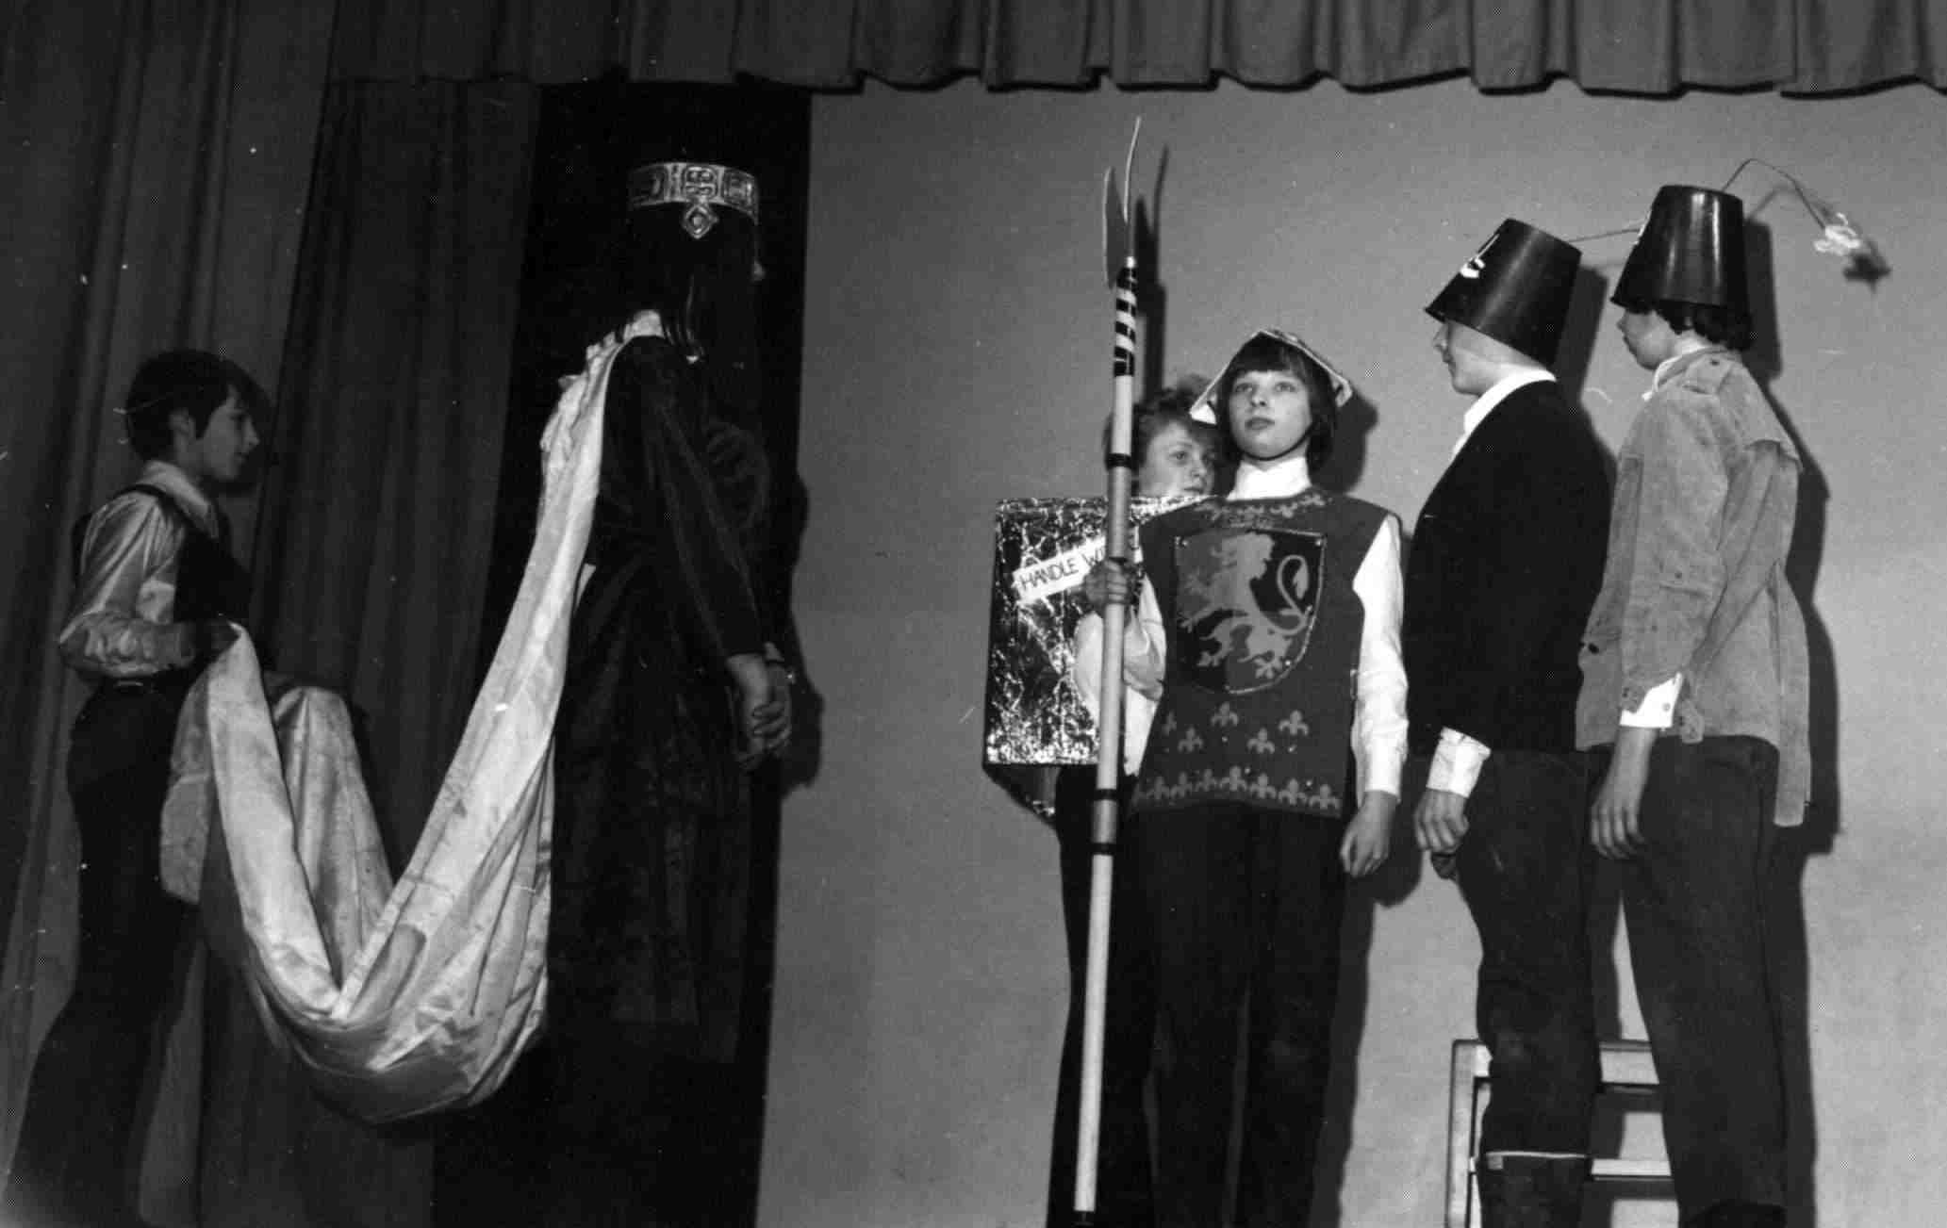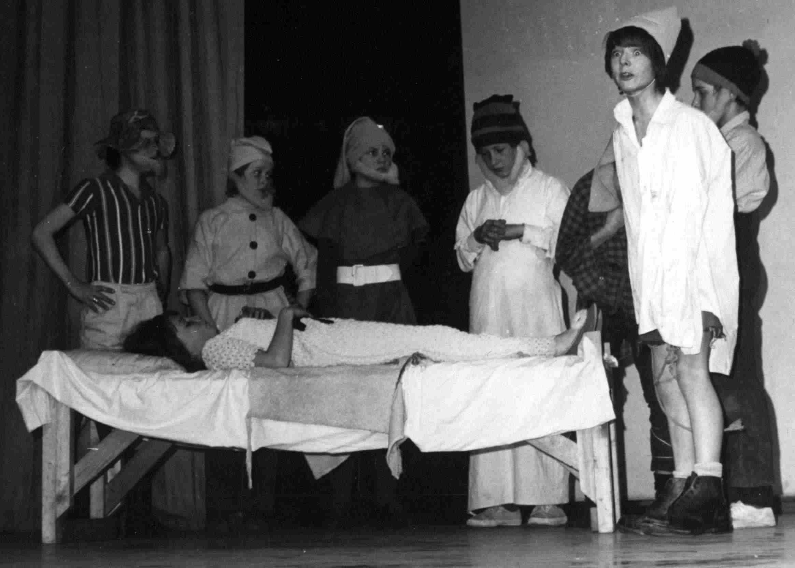
Photo on left shows a scene with the wicked witch (Gary Peters) consulting the magic mirror (Glenn Powling). Attending the witch in a very fetching pair of tights is Chris Venner, whilst Stuart Arthur (Pod) stands guard with Bill and Ben (Alan Beal and Kim Hornby).
The photo on the right shows Snow White (Russel Bridge) and the Seven Dwarfs, from left to right: Happy (Martin Smith); Grumpy (Steve Nicholls); Doc (Andrew Holmes); Sleepy (Paul Fahy); Bashful (Peter Stern); Dopey (Clive Stringer!) and Sneezy (Yours Truly, Keith Parr).
Other stars not depicted were Colin Usher as ‘Beanpole’ (the school caretaker at the time) and Chris Yates as ‘The Pig/Prince’. My theatrical career has failed to progress beyond drunken Karaoke since then but there were some very promising careers that I’m sure must have developed. Chris, Russel and Gary in particular seemed to enjoy their stage costumes.
Over the years since leaving school I have occasionally bumped into the following chaps: Martin Bain, Russel Bridge, Paul Fahy, Jamie Hillman, Steve Nicholls, Phil Knight, Bill Horlock, but it would be great to hear from some of the others from my class or year. . .
As for me :
Having spent the best part of 27 years in Telecommunications with one company or another, I was made redundant in December 2003. Since then I have been keeping the wolf from the door by installing kitchens and bathrooms and doing a bit of decorating etc. Much less financial reward, but much more fulfilling without the stress. I am also training to be a driving instructor. Married for 24 years with three adult kids.
Does anyone else remember when we put poor John Lineham in an overturned cast iron water tank in the field behind the woodwork shops and left him there all afternoon? Sorry John.

Roy Jenner - 1947-48
I think often of Dartford Tech. in Essex Road all those years away. Thought you might care to chart my progress, Miss Williams (Mrs. Mountjoy) would be pleased.
After leaving school at fifteen and spending three dreary years as a butcher’s apprentice army service at eighteen saw me involved with the colours for three years, two of which were served in Egypt’s Suez Canal Zone. 1955 saw me free of uniform to continue in the retail meat trade through North Kent and South East London. In 1956 I married Mary and in 1963 moved to New Zealand with our two sons where I continued in the meat trade until 1983.
The Auckland family of Jenners now consists of four sons, seven grandsons and three granddaughters. The transition to the real estate profession in 1984 proved to be a wise move and I have enjoyed considerable success with the nation’s top real estate company.
I have written short stories, poems and songs and had my latest novel published (On the Lip of a Lion) October 2004 in New Zealand by Hazard Press. For more details see my website. www.storyteller.co.nz
(I was pleased to hook up with Keith Chessell on this site after more than 55 years.)

Derek Windows - 1950 1953
Three weeks had passed since my last day at school. The memory of hoisting Mr. Clare’s bike up the school flagpole was fading rapidly and reality had kicked in with a vengeance. I had to find a job. There was conflict on the home front between my mother’s desire for me to find an office job and my father’s working class credo that there was nothing wrong with working with one’s hands.
Each day, dressed in my best suit topped off with my brother’s best tie, I accompanied Mum up to London. I actually landed a position as an office boy in an insurance company.
Since I had a fortnight’s grace before starting, I decided to look around locally. My brother, three years older than me, who rarely bothered with my activities unless he needed me to kick a ball around in the park with him suggested that I went down to Erith and tried for an apprenticeship at Fraser and Chalmers.
Once there Mr. Hinds the apprenticeship master interviewed me.
“What do you want to do Son?” he asked. The true answer to this question was ‘Nothing!’ but wisely I just looked blank. I honestly had no idea.
“How about being an electrical apprentice?” I nodded. “OK!” I answered. Mr. Brown was summoned. He was the foreman of the Electric Furnace Shop. “You will do two years in the shop here, then two years on outwork then one year in Wittons Birmingham, do you understand?” It sounded like a prison sentence but I nodded. “Start Monday 7am”.
6.45am Monday morning. I entered the main gate of Fraser and Chalmers.
I stood before the time clock. Dad had told me that that was the place to stand. I had no idea what to do! A fat man wearing a flat cap approached. “Who the ‘F..k’ are you?” he asked gruffly. I was stunned; I had never heard language such as that and dropped my toolbox. It missed the man’s toes by inches and he stepped back, an alarmed look on his face. “What the ‘F..k’ have you got in there?” “Tools!” I answered. “I’m the electrical apprentice.” “Christ!” he said. “You’re late! Have you clocked in?” “No!” “Well, there’s the b....y clock, punch in and I’ll get Wally the labourer to show you your bench.” I approached the clock, there was a lever sticking out so I depressed it. “Clang” it went. “What the hell are you trying to do, break the b....y thing?” The fat man grabbed my shoulder and dragged me sideways. “There’s your cards, if you’re out they are in the left rack, stick ‘em in the slot, punch ‘em and stick ‘em in the right b....y rack. That shows you’re in. Don’t you know anything?” Things were becoming a blur. Was I supposed to have been born with such information already impressed in my brain?
However I followed the instructions. The fat man then informed me that he was the chargehand and his name was Wiggins. Henry Wiggins.The problem was that Mr. Brown looked after two other departments as well as the EFS and Henry Wiggins had asked him to acquire a third year apprentice to help with an inrush of orders. Mr. Brown had failed to inform Henry that he had hired me, straight from Dartford Tech and as green as grass.
Wally strolled up. Introduced himself as the shop labourer and with a grunt and a heave he hefted my toolbox. I followed meekly behind as he led me down the shop to where I was about to start my apprenticeship.
Next to my bench was the door to the stores. From there issued a tall thin bloke wheeling a barrow loaded with Honeywell instruments, indicator lamps, rolls of wire and bags of nuts and bolts.
“I’m John, I’m the storekeeper and this stuff is yours. I’ll get you the blueprints later.” The overhead crane was trundling down the shop toward us and John gestured toward the huge steel cabinet dangling from the slings. “That’s yours too.” He said.
Henry Wiggins hove into view. “Got everything?” he asked and I nodded mutely.
“Well b....y well get on with it, there’s six more to make after that one.”
I was alone and surrounded by bits and pieces of unidentifiable equipment, and overshadowed by a raw steel cabinet with roughly cut holes in it. And six more to come.
John came back with the blueprints. “That’s the lot!” he said and I almost cried with relief. I wanted my mum! Where to start! I unrolled the blueprints. Luckily Mr. Collins my Technical Drawing teacher had given me enough knowledge to read blueprints and I slowly worked out what bits went into what holes in the cabinet.
The temperature controller went into the left-hand hole. Ok! Pick it up and shove it in. Easier said than done, the thing was heavy, very heavy! I got it onto my knees and with a supreme effort raised it chest high and level with the square hole. Damn, it wouldn’t fit. The hole was too small. Right. Try the recorder! It was the same size only heavier. Huffing and puffing I thrust it forward. It wouldn’t fit either. No wonder they used colourful language in factories! I was stuck with ‘Gosh!’ and it didn’t seem sufficient.
For days I hid and read comics. Hidden away from prying eyes I cowered every time I heard a footstep pass by.
Finally Wiggins poked his head round the corner. He was stunned. “Call yourself a third year apprentice!” He bellowed into my ear. “Look at this bloody mess!” “I’m not a third year apprentice.” I mumbled. “What the hell are you then!” Wiggins was quite red in the face. “I only left school three weeks ago.”
After a time on tedious work I was sent to De’Havilands in Hertfordshire to the Furnace Shop I did manage to halt all production by flooding the place. I was transferred to the Electrical Shop and was apprentice in Crane Maintenance.
From Frasers I moved To J&E Halls. Dartford. There I became, guess what! The crane man. I had my own fifty odd cranes and my own apprentice. My first words to him were, “What’s your sister like?”
Then, after four years at Halls I came home, dropped into a chair and asked Marion, “How much do you think we will get for the furniture?”
“Are you thinking of going to Australia?” she answered. How the hell did she guess?
It was all due to a film called ‘The Sundowners’ Starring Robert Michum and Debra Kerr , We loved it, all that open space.
Would you believe it! I now live on Dry Plains road. The very road in the opening scene of ‘The Sundowners”
(A full unabridged version of this article appears on the website titled Window Chap)

OBITUARIES
Tony Tipple (1951-54), emigrated to Portugal in June 2003 but unfortunately before he had a chance to move into his new house, he died, very suddenly, on 6 July 2003.

Members that were involved in the trips to Hanau, in Germany will remember Mrs. Marian Walkey, who passed away in July 2004.

Allen Hamerschlag (1970-84)
Allen was an active member of the EC of the Greenwich Society from 1982 until illness confined him to his house in 2004. He died on Saturday 26th February aged 75. Allen was one of those rare people who kept a low profile but was completely effective. . He thought up solutions to problems, could translate an idea into action and did not hesitate from the chore of carrying it out. . Whether this was providing 200 fruit tarts for a Greenwich Society party or thinking up a solution to Greenwich traffic problems. The sunken riverside bypass had been his idea. From 1982 until 2000 Allen was responsible for the Greenwich Society Newsletter and made it what was described as ‘compulsive reading’ having written typed, printed, stapled folded and addressed each copy and then delivered some 400. Shortly before he died it was he who worried the authorities until they made the improvements at Maze Hill Station frequently postponed ..
The Greenwich Society was not Allan’s only Charity nor his only interest. He was active in the Samaritans, and the Save the Children Fund. It was his idea in the 70s to collect small change leftover after foreign Holidays in the Charity’s shops. He would personally take the proceeds back to exchange for the Fund in their country of origin in h is car or ask his friends to do so. This idea has now been taken up by all Air lines and Travel firms. Princess Anne personally appointed him to work for her in the charity.
Allen was originally American born in New York. Summers spent camping in the woods of Massachusetts started his lifelong interest in plants and wildlife. A precocious student he had completed his University degree in Chemistry ‘cum laude’ aged nineteen. This lead to employment by the US Navy Department for experimenting with plastics which in turn ended by being ‘head hunted’ by an English Plastics manufacturer. He loved England and stayed taking out British Citizenship. His interest in modern painting took him from plastics on to start an Art Gallery. When this venture went bankrupt he turned to teaching Science subjects at the School. Allen loved to go to the Opera at Covent Garden, often with Marian Miller, or an Art Exhibition. He travelled widely and was working on an illustrated guide to wild plants when he died. It was for his collection of rare plants from Australia that he was elected a Fellow of the Linnean Society who named an orchid he discovered after him.
Allen had many friends in different places who will miss him. He leaves no Family. His legacy is to The Botanical Society of the British Isles to which he is leaving his house and other possessions. It is to be used for Young adults to go on courses to study botany and is called The Allan Hamerschlag Memorial Fund. Paul Grimmer (1978-85) will give a tribute on behalf of the boys at the funeral.

On going to press tributes are arriving to Allan
Many thanks for the notice, I knew Mr. Hamerschlag way back in the very early 80’s. I hope his extraordinary tie collection is going with him (the blue one made from macaroni was my personal favourite).
I will be unable to attend (I live in the USA now), but my thoughts will be with his loved ones on the day. With best regards. David Froud 78-83.

Thank you for letting me know. “Hammy” was my tutor for Chemistry in which I did get an O level pass so I remember him fondly.
He was a great man and very popular with us old boys. He joins the other greats now from my era: Maggie, Ivor Jenkins, the Honey Monster......
Please pass on my condolences. Kevin Cook 76-82

Please pass on my condolences to Alan’s Family. I now live in Cornwall and as such don’t often travel to Kent , however please pass on my regards to all who remember me. Ian Rendle 78-83

Thank you (sounds inappropriate, but you know what I mean) for the info. I’m sorry to hear of his passing.
I remember him well. He taught me for five of my years of Chemistry, with a small intermission from Mr Liddell ( Ladell? if I remember correctly).
I liked the guy very much and to this day can still remember the way he spoke. Didn’t he always wear a bow-tie?
That’s three of my three favourite teachers passed away; “Percy” Black, Colin “Basil” Newbury and now Alan Hamerschlag. How sad. Nigel Anscombe 75-82

I am sorry to hear about Mr Hamerschlag.
I was a pupil as long ago as 1970 - 1977. It is a mark of the man that I have never forgotten him. Some would say he sticks in the mind as the ‘Dandy’ with the bow tie and the funny accent, but I remember him as a really nice and genuinely funny guy.
Please add my name to any book of condolence. Steve Moffat 70-77

Thank you for passing on the sad news.
If you are able to do so kindly pass on my condolences, however he never actually taught me thus I shall not attend the service.
Good to see the website active again. Regards Trevor Dann 72-77

Thank you for the information. It is very sad news.
Unfortunately I will be unable to attend as I will be working in France that week.
Best regards, David Philcox 77-79

Association News
Arrangements are well in hand for this years Dinner and we have agreed to continue with the same format of a conducted tour of the School in the Afternoon followed by the Annual General Meeting and then the Dinner with our usual large display of memorabilia, although we will be without Neil McKay to organise it this year as he has had to retire from the Committee following his move to Ireland. Neil sorted out, and reframed where necessary all the pictures that John Daley had started to gather and the rest that have been donated since. They are stored in our cupboard at the School. Of course our Licensed Bar will be available for alcoholic and non-alcoholic drinks following the return of the touring party and until everybody has retired for the evening.
We have decided not to have a Guest of Honour at this years Dinner, but as we normally conclude our evening with a few speeches we are suggesting that we could invite a few members to speak for five minutes about there own experiences while at School or/and since leaving. We are sure that there are a few Members who would like to have a say. We would appreciate any volunteers for this as soon as possible so that we can make our final arrangements (dennis.wells1@ntlworld.com)

The Menu will be as follows:
Starter
Duck and Orange Pate
*********
Carvery Main Course
Roast Beef with Horse Radish Sauce
Roast Turkey with Cranberry Sauce
Vegetarian Option
Roast Potatoes
Selection of Vegetables in Season
**********
A selection of Sweets
**********
Coffee and Mints

We have kept the ticket price at £18.00, the same as last year. The application form for your ticket can be found in this Newsletter, please apply early so that we can confirm numbers with our caterers. Wives/partners are always welcome to attend.
Tickets can be reserved via the Internet (oldboys@odwa.co.uk), butbookings will not be confirmed until payment has been made to our Treasurer Keith Potter, details on application form, enclosing a S.A.E. will save a lot of work.
Our thanks to all members that added donations to your ticket money for last years Dinner, also those that tendered their apologies and sent a donation, we need these donations to save having to start a Membership Fee, which creates a lot of work, plus will no doubt cause a lot of those that we have contact with at the moment to sever that contact. So once again we continue the appeal for donations, even if you are not able to attend the Dinner.
Owing to a shortage of articles it has been a struggle to put this Newsletter together and caused the cancellation of the October/November Issue, so please start writing. The Website is active again, although we are still having problems with the update forms, any amendments can be registered by sending them to our email address: oldboys@odwa.co.uk

35 YEARS AGO
The Members of the 1970 Intake are hoping for a
good attendance at this years dinner to
Celebrate the 35th Anniversary of starting at the School
For more details contact Clive Stringer
clive_stringer@hotmail.com
or Marc Ellerby (Robertson): marc.ellerby@speltd.co.uk

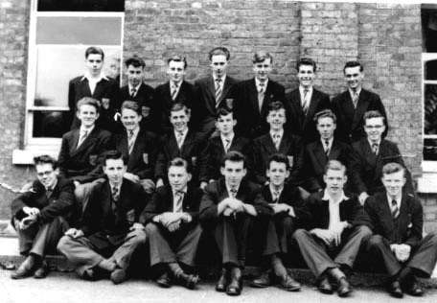
School Prefects 1955-56. Can anybody name them all.

12th ANNUAL REUNION DINNER & A.G.M.
on Saturday, 14th May, 2005
There will be a Carvery Dinner and of
course a Licensed Bar and a
Conducted Nostalgia Tour.
All ages are Welcome.

13th ANNUAL REUNION DINNER & A.G.M.
on Saturday, 13th May, 2006
Our Guest of Honour will be announced later.

If you wish to find former School friends and
get more of your own age group together do
not hesitate to contact us, as we have the
original Intake lists and facilities to
make comprehensive searches.

Visit our Website and check out the names that we have, and if you know any members not listed give us their details
www.odwa.co.uk email: oldboys@odwa.co.uk

Your next Newsletter is due to be published in February 2006
but to do this I need more articles and correspondence.
Comments with regard to your memories while at the School, experiences
at previous Reunions or details of your own life since leaving will be
greatly appreciated.

Please contact Dennis Wells,
3 Millbro, Victoria Hill Road, Hextable, Swanley, Kent BR8 7LF.
email: dennis.wells1@ntlworld.com

This Newsletter is made up from contributions of Members and the views expressed are those of the individual and not of the Association.

Mr. Keith Potter, O.D. & W.A.,
11 Thirlmere Road,
Bexleyheath, Kent
DA7 6PU

I would like ............ tickets @ £18.00 each
for the 12th Annual Dinner on Saturday, 14th May, 2005.

Name.......................................................................................
(PLEASE PRINT)

Pupil/Staff at School from .............................to ..............................

Address

e-mail address .....................................................................................

Vegetarian Option required ............

Cheque, payable to ODWA enclosed for £.................... includes donation to Association Funds.

I would like to join the Nostalgia Tour at 3.45p.m. YES / NO

Newsletter by email/post.

Association may publish/may not publish email address on website.

Association may/may not give out my email to other members on request.

