
DARTECH AND WILMINGTONIAN

A NEWSLETTER FROM YOUR OLD SCHOOL

NUMBER 26 MARCH 2012
18th ANNUAL REUNION DINNER & A.G.M.

on Saturday, 12th May, 2012
Brian Titterington (Headmaster 1991-2006)
is to be our Guest of Honour.
A 4 Course Dinner and of course a Licensed Bar and a
Conducted Nostalgia Tour.
All ages are Welcome.

19th ANNUAL REUNION DINNER & A.G.M.
on Saturday, 11th May, 2013
Our Guest of Honour to be decided

If you wish to find former School friends and
get more of your own age group together do
not hesitate to contact us, as we have the
original Intake lists and facilities to
make comprehensive searches.

Visit our Website and check out the names that we have, and if you know any members not listed give us their details
www.odwa.co.uk email: oldboys@odwa.co.uk

Your next Newsletter is due to be published in March 2013
but to do this I need more articles and correspondence.
Comments with regard to your memories while at the School,
experiences at previous Reunions or details of your own life
since leaving will be greatly appreciated.

Please contact Dennis Wells,
3 Millbro, Victoria Hill Road, Hextable, Swanley, Kent BR8 7LF.
email: dennis.wells1943@btinternet.com

TERRY MOYLE’S MEMORIES OF DTHS FOR BOYS (1966-1972)
It was 1966. I was a student at Goldsmiths College in my final year doing a PGCE following a three year degree course. I had been on an interview in Bexley but didn’t get the job when I saw an advert for a Geography teacher at DTHS for Boys. I didn’t know anything about Dartford or the Dartford area but, as I wanted to stay in the London area so that I could still go to Saturday First Division football, I decided to apply. I cannot remember whether the advert was in the TES or on the notice board in the Geography Department at Goldsmiths though I think the latter.
I sent in my application and was called for an interview. I came to Dartford from New Cross on the train and then caught a bus to Wilmington post office. However, I missed the post office stop (didn’t expect the PO to be a Co-op) and eventually got off the bus as it neared Hextable. I walked back to Wilmington and eventually arrived for the interview. The Head (John Mogford) and the Deputy (Percy Black) met me and Mrs.Norman made me a coffee. I cannot remember much about the interview, the questions asked or the trip around the school, but I was offered the job. I might even have been the only applicant!! I was replacing Pip Cartwright and working in the Geography Department with Ian Smith, the HOD.
My first timetable was interesting – as a Geographer, I found myself also teaching some History, RE and PE. This is what happened to NQTs in those days – you were expected to teach several subjects so it wasn’t too much of a shock. I was delighted to see that I had quite a lot of AL work. Despite only being four years older than the Upper Sixth Geographers, the prospect didn’t daunt me. I was teaching both Physical and Human Geography, including a regional paper that had the options of Brazil and Western Europe, my specialist areas of knowledge. I was happy with both History & RE but PE was a different matter. I was not really a sportsman though I enjoyed playing tennis and watching football.
I don’t remember much about my first year of teaching (1966-1967) except that the atmosphere in the Staff Room was very friendly – all male except for Mrs.Mountjoy who seemed to take me under her wing. Staff meetings were fabulous compared to more recent years – Mr.Mogford would come in at break, say “Good morning Mrs.Mountjoy, gentlemen” and proceed to make his announcements. At the end he thanked us and went. They were always held at break time so there was always a time limit.
Ian was a great Head of Department and was happy for me to teach in my own way as long as I covered the syllabus. I was warned by Clive Dougal not to sit in front of Mr.Lawson at Assembly (staff were on the stage) as he was inclined to pull the chair away from under you at the end of the hymn. I always had school dinners and took my turn on duty by saying Grace. Reggie Bruce always said his grace in Latin but mine was simple – For food, friends and fellowship, we thank you Lord. Looking back, what great students we had – they came in for lunch, stood up in silence for the grace and then went to collect the food.
For probably the wrong reasons, I remember the Wednesday afternoon Games lessons with the Sixth Form. On one dreadful occasion, Gavin Russell gave me a basketball match to referee in the gym. I knew absolutely nothing about basketball so he gave me a lesson on the rules beforehand but it was still a disaster. Fortunately, the boys were sympathetic to my plight and helped out with refereeing decisions! On another Wednesday afternoon, the PE Department (Gavin Russell and Mike Upton) had gone to another school for a cup match, leaving me in charge of all the Sixth Form games. It was pretty horrendous from what I can remember as one student (cannot remember his name) decided to play the fool and me up.
After my first year, Games disappeared from my timetable and gradually History and RE also went. However, at the end of my probationary year, Mr.Mogford called me into his office and told me that he was pleased with my work, including and especially my AL teaching, and as a result was going to reward me with a scale post. Those were the good old days when teachers could be rewarded simply for good teaching. I didn’t have to take on extra responsibilities as has happened in more recent years within the profession.
In my second year of teaching I was given a Form to look after – Mr.Black told me that I would have a good form so he gave me 3M, who had been brought up by none other than Mrs.Mountjoy (hence the M). I really enjoyed the pastoral work and took 3M right up through the school as 4M, 5M and into the Sixth Form. When they left in 1972, it was time for me to go as well but that will come later.
DTHS was a great school in which to start my teaching career. I regularly went to Mrs.Mounjoys for dinner though I was expected to be the cabaret by singing for my supper. She was always keen for me to look after the French Assistants and introduced me to Mlle.Danielle Destinay. Danielle and I enjoyed our social life but after her year at the Tech went back to France. I also went around with Pat Rudman (English) and Mike Upton(PE). On Fridays we all went to the Dart pub in Chastillian Road where we met up with other staff including Mr.Black (and Mrs.Black), Paul Parker and several others. I got involved with supporting the First team and regularly went to Saturday morning football matches both at home and away. The lovely long lunch hours meant that the staff could play tennis and I managed to play as often as the weather allowed. This involved a number of staff and Sixth formers. I also started up a Sixth Form tennis team and for several years arranged fixtures with other schools. We had a good team and they won far more matches than they lost.
Paul Parker roped me in to help with the running of the school tuck shop. We were doing this at the time that decimal coinage was introduced so had to be trained ourselves and train the boys who helped. I also started a Dance Class on a Wednesday after school for the Sixth Form – I had been going on a Friday evening to dance classes at Welling so knew the steps to pass on to the boys. Before you get too worried about boys dancing together, we “imported” the Sixth Form girls from up the road who came along with Mrs. Sheila Wakeford from the Girls Tech. The classes were a great success after the initial shock of the boys actually holding a female partner for some ballroom dancing. Jim Joyce the school caretaker ran a dance band so we held Sixth Form dances at the end of every term. They were well attended and any boys who had not been to the classes were given a quick lesson or two in the lunch hour on the days before the end of term dance. What a success they were, including several romances that led to wedding bells!!!!
Geography field trips were something special – the OL groups did field work locally and on the South Coast but the Sixth Form AL groups always went on residential trips with Ian and myself. We went to Pitlochry (Scotland), Slapton Sands (Devon), Pembrokeshire, Whitby (twice) and Shropshire. These were a good mixture of hard work and fun. In Whitby on one occasion Tim Newton went missing quite late in the evening so we went out searching for him in a nearby graveyard. On another trip MR (Mike Richardson) got embroiled with a female student from another school so Ian had to give him some man to man advice.
I also went on School Trips with Len Hollingsworth for several years – we went to the Netherlands (staying in The Hague) in March/April 1967, to the Rhinelands at Easter 1968 (staying in Bad Honnef) and to Scandinavia in the summer of 1969. The Rhinelands trip turned out to be a real adventure. On our fourth day there Len was rushed to hospital with severe appendicitis in the middle of the night and had to have an emergency operation. He was our only driver for the minibus as I was in charge of cooking and was not down on the Green Card as a driver. Fortunately, after spending a day at the British Embassy in Bonn trying to sort out money, insurance and the Green Card, I was able to drive the minibus for the rest of the stay. We left Len in the hospital and he flew back to the UK about a week later. This was really a baptism of fire for me – I was only just 25 and eligible for driving a hired minibus abroad and I had never driven on the continent before. Having got clearance from the KCC, the school and the Insurance co., I went out on a test drive remembering to drive on the right and to negotiate roundabouts the wrong way around. Len also had to pay up front for his operation so we had a whip around before the op and then had money sent out to cover the rest of the costs. On the way home in the minibus we only went wrong once – at Aachen we went into the Netherlands instead of Belgium so had to do a quick U turn, come back into West Germany and try again. In those days passports had to be stamped as you crossed political boundaries so we had extra stamps. These Sixth Form trips were in theory field trips for Geography/Economics students where they had to write up an account of the journey but in practice they were a lot of fun as well. Trips around car factories and shipyards, visits to cathedrals and HEP stations and cooking our own meals were all part of the enjoyment. When we were in the Rhinelands we met up one evening with the DTHS football team in Koblenz who were out in West Germany on a football tour. When we were in Scandinavia, we were based in southern Sweden but went into Norway and had a couple of days in Denmark.
I also managed to go on a school journey which was led by Mr.Black – the visit to Switzerland at Easter 1969 when we got stuck in the snow on the way to Interlaken. We spent hours on the coach as we had to come back to our base at Vitznau, near Lucerne, on a very circuitous route via Berne as we could not get over the mountains. There were never any problems with Mr.Black in charge.
I have good memories of colleagues on the staff. Mrs.Mountjoy was unique in many ways as the only female member of staff although her nose was put out when Mrs.Mary Evans came into the English department for a while and then Doris (forget her surname but it could have been Peacock) came to teach Music – Maggie had competition. Messrs Dougall, Hollingsworth, James and I played tennis regularly and Pat Rudman was always up for a laugh. This reminds me of one occasion when I was walking by his classroom – there was absolute mayhem and no sign of Pat. I opened the door and shouted, the boys went quiet and suddenly Pat appeared from the cupboard. On one evening out Pat, Mike Upton and I went to Bingo in Kent Road (in what is now the nightclub) - how sad was that??!!!! A group of the staff always went out on a Friday evening ending up in the Dart. Ian Hugh who taught Physics for a couple of years and I went around together as he and I were part of the “unwilling” PE teachers on Wednesdays – we could never take Games seriously. (Sorry Gavin). We also took Ian Smith to the cinema in Sidcup on one occasion to see “Here we go round the Mulberry Bush” which was rather a racy film at the time, though very tame by today’s standards.
I remember one summer lunchtime in particular, probably in about 1970/1971. We had a bomb alert at school and everyone had to assemble on the tennis courts for a register check to ensure that the building had been completely evacuated. However, most of the Upper Sixth boys were missing so Mr. Mogford asked me to scout around for them. I knew exactly where they were - in the Foresters up the road. I went into the public bar and there they were. I ordered them in my best school teacher voice back to the school immediately - they went without drinking up and the bar was empty in seconds. What power!
In those days when I was on duty or it was cold in my room, I always wore my gown. This had an amazing affect on the boys - they always thought that I was in a bad mood when I wore it (when lining up outside the room, the boy in the front would shush the others saying “he’s got his cape on so be quiet he’s in a bad mood”).
I remember many of the boys and still enjoy hearing from them on social websites or even meeting them. I actually met Bill Stoneham in 2009 when he came to my school as an Ofsted inspector, the first time I had seen him since he and I left DTHS in 1972. Whenever we met in the corridor or on the way to a classroom we talked non-stop about the good old days at the Tech. I went to Anton Syrocki’s fiftieth birthday party a few years back and met many from the old 3M. Chris Proctor, Howard Little, Anton Syrocki, John Hayes, Paul Saunders, Fausto Fabi, Steve Marsh, Graham Field, David Munford and John Walker were there and we caught up on 30 years of news. We had photos taken - what a great evening!
After spending six very happy years at DTHS (1966-1972) I decided that I should move on to further my career so I decided to look for other posts and was appointed Head of Geography at a school in Chislehurst. I was sorry to leave the Tech but the time had come for me to move on. I could not have wished for a better school in which to start my teaching career. As I have now retired after 43 years of teaching (was I mad or dedicated?) I look back on my time at DTHS with great affection. I even have all my mark books from those days so that the names of students that I taught are still with me in writing if not in actual memory, though I am usually able to put faces to names when I see them.

David Savage - (1941 - 1943)
As was the case with many of my contemporaries, (I was born in 1928), my education was disrupted by the outbreak of WW2. In effect I lost the best part of a year and hence, when I came to sit a test for admission to Dartford Grammar School I was unsuccessful. With hindsight this proved to be a blessing in disguise!
Within a few weeks however the opportunity came to sit an entrance exam for the County Technical College in Dartford. This took the form of intelligence tests and tests of mechanical aptitude etc. which suited me much better. Luckily I passed, and in the September of 1941 started at the first school which I had ever actually enjoyed attending, and one which I feel offered a really useful and worthwhile two year course which formed the basis for a future career.
Access, from my home in Welling was, on most days, by cycle, five miles each way, good exercise!, but in inclement weather by the frequent service of trolley buses, practically door to door. Prior to starting my father found an advert in the local rag for a second-hand Raleigh. We went to see this and purchased it on the spot. It was a rather superior machine with a Sturmey Archer 3 speed, controlled by a lever on the handlebars, and it was equipped with a dynamo lighting system. This was to serve me well for 15 years and several thousand miles. He also acquired for me a slim, gold plated, evening dress type pocket watch, which served me for the next six years. I did not have a wrist watch until my 21st. birthday! Watches were virtually unobtainable during the war years, and it could take six to nine months to get one repaired. Even the purchases of an alarm clock required the production of an “essential worker” certificate!
September 1941 to July 1943 was a relatively quiet period air attack-wise, post London Blitz and pre V1/V2, but a few months after starting at the Tech. Dartford became part of a restricted area stretching to the coast, with a border at the bottom of Princes Road. This meant that one had to show a pass to officials who boarded the bus at that point, or flash it as one cycled past. This restriction was to last until well after D day. Incidentally, Princes Road was lined with oil burning smoke screen generating devices which I don’t think were ever actually used in anger.
Dartford Tech. was split between two sites. Class rooms, labs and an eating area were located in an old brick building, with a further two classrooms in a corrugated iron annex, which was still there in 1967 but appears now to have gone. Behind this was the cycle shed. There was no proper recreational area anywhere on site. All this was in Essex Road, whilst the workshops and two gyms. were a quarter-hour walk (through the town centre) away in Lowfield Street.
Buildings on the Lowfield Street site were brand new, and next to them was a big excavation which was to have been the basement of a new classroom building had war not intervened.
The curriculum excluded foreign languages, but included engineering drawing, woodwork and metalwork. I still have some of the tools I made in metalwork, but unfortunately not the rather nice in-laid book holder and T-square resulting from the woodwork activity. The “academic” part of the curriculum included subjects such as mechanics, electrics, physics, chemistry, history, geography, English, maths. PT sessions were conducted in one of the two magnificent Lowfield Road Gyms., generally the lower one. As part of the English we had to prepare and deliver short “Lecturets” in front of the class, which was a bit unnerving at the time, but which I now think was a good idea. The staff were all good at their job and, by and large, friendly. The Principal was a Mr. Mc. Bretney, but we saw very little of him. The College was run by the Head, a Mr. Wall who had served with the Royal Artillery in France during WW1. He used to take us for Current Affairs, and looking back, his views were far from reactionary. His bete noir was Mr. Baldwin. Chemistry was taught by a Mr. Barr and PT by a Mr. Harris. There were only two female members of staff, a young one who took us for history, and an older lady who did geography and religion.
The course lasted two years, entry being aimed at 13 year olds, and there were three classes in each year. There was also a 2 year Commercial course, which included Spanish, but we did not have much to do with them. Our class teacher for the two years was a Mr. Howard, who also took us for Engineering Drawing. He had a somewhat sarcastic attitude, but he wanted us to be the best class of the three, (T1a, T1b and T1c) and he inspired in us a desire to succeed in that aim.
We did quite a bit of walking through the town, (carrying gas mask in a cylindrical metal container), since Assembly, PT, Wood work and Metal work were all at the Lowfield Street site, whilst academic subjects were taught at Essex Road. Then, one afternoon a week, there was an even longer trek to the sports ground on the other side of the railway. In another building at Lowfield there was a fully equipped machine shop, but we never got to use any of the equipment there because it was being employed full time for the production of components for the war effort.
I became friends with classmate Ian (Nobby) Clarke who also lived in Welling. We used to cycle back together, though rarely in the other direction since he tended to arrive late. Going home there were two hills which had to be walked up. The first was Dartford West Hill, the second was Bigs Hill, between Crayford and Bexleyheath. At the foot of the latter we discovered a tiny shop from which one could get a slice of fruit cake which went down very well at that time of day. However this only lasted a few months until food stringency became such that such un rationed luxuries were no longer obtainable. Nobby and I competed for top position in the end of term class exams.
Neighbour Alan Smith, from 11 Danson Mead was also in my year, but in a different class.
Unfortunately in, I think, the Spring of 1942 he was cycling back from the sports ground and came into collision with a trolley bus coming down West Hill. He was killed instantly. Nobby and I came on the scene a couple of minutes later and wondered whether we should be the ones to tell his mother, but luckily by the time we got back to Danson Mead there was a police car outside No.11, so we didn’t get involved. We did however go to the funeral at Plumstead Cemetery, and I remember being impressed by how deep the grave was. Afterwards we popped into the Odeon to see a film about the life of Amy Johnson which did not cheer us up at all.
For the first year we took packed lunches, but then a scheme of bringing in hot food in containers was introduced so that, for money, one could have something more substantial. As an alternative there was a British Restaurant at the bottom of Essex Road where one could get a set two courses for, I think, one shilling. The introduction of money into the system meant that one also had the possibility of going hungry and augmenting one’s pocket money for more nefarious purposes!
An Army Cadet Force Company attached to the Royal West Kent Regiment was formed at the school c. March 1942. The Company Commander was Captain Wall (Headmaster). It consisted of four? c.30 man Platoons. I enrolled as a just fourteen year old Lance Corporal in the Platoon which was commanded by 2nd. Lt. Hutchins? (Woodwork Teacher), with Platoon Sgt. George Milton (fellow pupil). Mr. Harris commanded another Platoon, whilst a third was in the charge of the Physics teacher.
The first camp was held in the Spring of ’42. It took the form of a week in army bell tents near Lullingstone Park; quite a fair march from Dartford. The highlight was a visit to a nearby Army “Fair”, with demonstrations of explosions, sticky bombs, Bangalore Torpedoes, assault course etc. One evening the whole Company marched to the local cinema in Swanley?, where the performance of the film, “Top Hat”, was held up awaiting our arrival. Marching back to camp in the black out pitch dark we annoyed the officers by striking showers of sparks off the road with our hob nailed boots!
For the rest of the year parades and instruction were confined to Saturday mornings, with the odd evening event thrown in. We were introduced to the intricacies of the Bren Gun and three different marks of Sten Gun, all pretty lethal to the operator. We were taught map reading, a skill useful in after life, we carried out practical exercises on Dartford Heath and, of course, we mastered the intricacies of arms drill. Our target was to pass the tests required for the award of Army Cert. A, which was achieved eventually. The second camp was held, again in bell tents, on top of a hill just south of Tonbridge, in the Spring of ’43. Access to Tonbridge was by rail from Dartford. Highlights of this camp were a series of talks given by officers from various exotic organisations, such as the Intelligence Corps and the Reconnaissance Corps, each extolling the virtues of their particular group.
The Cadet Force was quite a worthwhile experience and probably made the later starting of soldiering for real a little less of a shock than it might otherwise have been.
One of the annual Prize Giving evening events which took place in the upper gym. was honoured by the presence of the commander of a submarine (HMS Mars?) who handed out the books. Towards the end of our second year the class was taken on a visit to the engineering factory of Halls (the Dartford engineering firm in which Richard Trevithick ended up). There were calls of “you’ll be sorry” from some ex Dartford Tech. lads employed therein, and the general ambience put most of us off the idea of getting stuck with a factory job!!
In the July of ’43, aged 15, I finished my two year course at the Dartford Tech. with some regret. Just prior to leaving the College organised an evening dance in the upstairs gym. This was quite a new experience for most of us, and I think for the College. I remember the younger lady member of staff trying to give us beforehand some idea of what was involved and what to expect. (I think our generation was some what naive when compared with present day youth!). In the event a load of girls were bused in from, I think, the Bexleyheath Technical College for Girls. Music was played, soft drinks were supplied and, although not much serious dancing was in evidence, a pleasant warm summer evening resulted.
Dartford Tech. had equipped me with useful knowledge, skills and experience but, apart from a Reference from the Principal, no actual paper qualifications. The eventual acquisition of those is another story…
.
TROLLEY BUSES
In Bexleyheath trolley buses replaced the trams in 1935. Route 696 ran from Woolwich Ferry to Dartford Library via Welling, whilst the 698 ran from Woolwich Ferry to the Bexleyheath Clock tower via Erith. They provided a superb service. At peak times there would be a 696 bus every one and a half minutes. The vehicles were practically silent in operation and there were no exhaust fumes. They were capable of rapid and smooth acceleration and deceleration, there being no gear changes, and they had seating for 60 passengers. The buses were based in a large purpose built depot located on the Erith road, just a few hundred yards from the Clock tower.
In war time they provided a vital 24hr. personnel transport facility, particularly for large factories, such as Woolwich Arsenal and Vickers at Crayford, whilst making no demands on critical oil supplies. At 3.20am on 29th. June 1944 the depot was hit by a V1 and set on fire, rendering all 84 vehicles therein unfit for service. Twelve were completely destroyed and 26 needed re bodying. However London Transport drafted in enough buses and trolley buses to run an almost normal service by that evening. (Riding the top deck of a windowless trolley was quite exhilarating!)
Sadly, the service was terminated at the end of February 1959 when the trolleys were replaced by noisy, smelly, juddery Routemaster diesel buses.

Roberto Viegas (1976-1983)
What a marvellous Website. Keep up the good work. Thank you for persisting over the many years for sending me the Newsletter. It feels good to belong.
My favourite Teachers: Mr Jenkins (Metalwork), Mr Wood(?) (Woodwork), Mr Williams (Physics) and his Assistant who drew ‘halo’s’ over his i’s, the sexy Maths teacher, and the German teacher.
Most memorable moment: The canal boat trip with Mr Jenkins and Classmates.
After A-levels, went to Salford Uni to read Electronic Communications BSc. Passed on into Industry via a graduate training program with Mercury Communications (Cable & Wireless). Didn’t like commuting and found London too big ... Tried various other jobs, around the Country, but felt lonely so sold up and bought a Ford Transit Camper and toured Europe, visiting old school friends from my previous school St Augustine’s. Eventually ended up in Portugal, where Carlos helped me find my feet. I liked living with the Portuguese, and taught English at the Cambridge school in Lisbon, went to Jazz venues, and was surrounded by sexy female teachers, had the splendid beaches to enjoy, and finally ended up buying 50% of the Sandwich Bar, in Cascais, where I was constantly surrounded by interesting people which I enjoyed thoroughly. Tried Marijuana and liked it. Met my ex-wife there and together visited a lot of Portugal. But the marriage had its consequences with so much arguing that soon followed leaving me with little processing power and so I made some daft choices (in retrospect), and sold the Sandwich Bar, and gradually spent the capital, becoming completely broke and finally divorcing penniless, and eventually homeless in sunny Portugal. It was a productive time thereafter being in need, overcoming many taboos, gaining good friends, and finding Faith through Nichiren’s Buddism via Manuela’s group. I worked hard to achieve the a Gohonzon. I was working on a compatibility system so as not to make the same marriage mistake again, which has held me in good stead. Received my first vision where all of a sudden I saw the vision in front of me split up into its basic component, swirling energy. ie each person on the beach looked like a spinning vortex. I worked for a kind Jewish man driving kebabs around Portugal, and met another sexy woman with two boys, who helped me a lot with my portuguese. After our trains headed off into different directions, I had a second vision when sitting on a overhanging cliff ledge with a friend, with the sound of the Oceans fringe lapping at the ledge. I saw the millions of crests of the agitated water turn into millions of hands (and fingers), and I got quite spooked and with the tide coming in and then finding difficulty in scrambling up the 7 foot cliff face! Learnt to read Tarot, and met many clairvoyants and other readers. Ended up going to jail falsely accused where I had my 3rd vision and was hardened for the job ahead, before my ‘escape/return’ to England in 2000. Was termed mentally ill as I couldn’t serve two masters. Was given a nice place to live in Dartford centre with income support. Found I liked selling on eBay, but it got too successful, and had to stop. Was then extradited back to Portugal to complete the trial and sat in jail feeling safe for a number of weeks before being completely cleared.
Back to England, and because no one had given me the benefit of the doubt my flat had been vacated a week earlier and I was first dumped into B&B and then Temple Hill where I have been passing on messages and doing my spiritual work. England hasn’t changed for the better, less places to frequent, more cold shoulders and general loneliness. Can’t wait to leave!
Most scary moment: Sitting on a ferry in a tremendous storm between England and Belgium with the waves higher than the ship, everyone being sick, screaming and/or panic stricken, with crockery pots and pans flying out of cupboards, and just thought it was the end.
Hope this helps to fill in a bit about this lifecycle of mine.
Kind regards, Roberto.

Adrian (Stan) Sutton (1967-1973)
Since October 2011 I have reduced my working hours to 50% as Professor of Nanotechnology at Imperial College. In the end the commuting between Oxford, where I still live, and London became unbearable on the bus and ridiculously expensive on the train.
I am planning to return to some research and writing after 6 years of management and leadership roles. I am also planning to have more fun before decrepitude sinks in. To that end Pat, my wife, and I took off to Key West on October 1 for 10 days and we will travel much more together in the next few years. Establishing a more sensible work-life balance is a top priority.
Having given several talks in state schools recently I have been very struck by how fortunate I was to have had the benefit of a good state education. I have been truly shocked, not to say horrified, by the inadequacy of the education offered in science and maths in the state schools I visited. Mr Grayson and Mr Bruce gave me a far better education than anything I have seen in the state sector recently.
I also had the benefit of no university fees and a generous full grant as an undergraduate at Oxford. How things have changed!
Some of the time I now have on my hands I intend to use to “pay back” for my good fortune for being born when I was.

Peter Ferris (1963-1968)
Dear Sir,
I feel it only fair to inform you of the fact that I have recently learned of ‘clandestine’ meetings taking place regularly which involve ‘old boys’ from DTHS for Boys. I clearly remember the people involved being of a rebellious nature and would like to make you aware of them and the threat they pose to other decent and hardworking ‘old boys’.
Please feel free to ‘name and shame’ those involved:
Ian Bell: believed to be the ring-leader and one-time cricket fanatic.
Perry Scoffield (Not Schofield): Manchester United supporter - enough said.
John Wakeford: AKA “Wackers”. Former Lambretta owner and ‘crop-headed’ teacher’s pet (‘Tutters’ especially).
John Drury: Lived in a gingerbread cottage in Rowhill Woods. Vespa owner.
Graham Baxter: AKA “Baccy” due to his penchant for things prefects looked out for. Vocalist in school ‘pop group’.
Peter Ferris: AKA “Fungus”. Bass player in above group. Ostracised by bullying gym teacher for not dobbing-in AJ White. Ejected from DTHS by a cruel Pudding.
Nick Pell: No nickname. No scooter history. No musical associations. Suspicious.
Last known whereabouts: a pub in Horton Kirby related to gender inquiries.
Anyone knowing the whereabouts of these or any other ’63-’68 scholars is invited to post comments on the website at www.odwa.co.uk
Thank you.

Frank Marsh - (1939-1941)
Principal was W. McBretney. Due to the outbreak of war, my class was only allowed to attend a couple of days each week due to air raids, but we had quite a bit of homework to take back for marking. I started full-time classes in the Spring of 1941. I hope to send you a short account of my rewarding experiences shortly. By the way, it was known as Dartford Technical College at that time.

Richard Man - (1974-1977 Staff)
I remember with deep affection Mr Black, diminutive Scot with deep respect for truth, honesty, hard work. A deputy-head who acted as a true mentor and supporter of young teachers. In my first week of teaching he burst into my class.... “Gentlemen!” addressing the boys, “ Mr Man is a fine teacher... if you mess with him ... you mess with me.... and you know what that means?” The rest was silence! He made us feel wanted. I loved the school and regret the day that I left thinking I was going to pastures greener...’

Frank Pearson - 1957-196
I am writing this letter on New Year’s Eve 2011, which is a significant date for the Class of ’57. All of us were born in the year 1946, so reached pensionable age during 2011. We envisaged this in 2007 and decided to make every effort in 2012 to get out in force for the Annual Reunion Dinner. Hopefully this letter will be published in time to remind the class to attend.
It may surprise younger readers that pre-1958, most people sat the 11+ aged ten. The move from Calendar Year to School Year qualification occurred the following year, where the post-war bulge meant that three forms could be filled by pupils born between January and August 1947. The switch seems to have been confined to Kent and explains why the four form entry of 1957 was a on-off for man years.
I could have worked until at least my 65th birthday, but decided to retire in Summer 2008 so as to convert my pension into an annuity before rates declined. However in the same firm, still beavering away was one Robert Crighton from the class of ’56. With legislation having gone through Parliament to allow a right to work beyond 65, I guess he’s still there exposing his genius.
Hopefully the Class of ’57 have all retired and they will be able to turn out in force to the next dinner.

Alan Smith - (1945-1948)
I’ve just been been looking at the ODWA site and thought that I would let you know that I am still alive!
I attended Dartford Tech from 1945 till 1948 and can identify with some of the older members reminiscences such as VOD, (Mr McCaskell) the maths teacher. He was a bit of a stick in the mud but I learned a lot about maths from him. Mr Cutler used to teach technical drawing and Mr West woodwork. I can’t remember any others at the moment. We used to call the PE teacher in Lowfield Street Charlie Harris although I’m not sure that that was his name.
One member of staff I do remember was Rhoda, a secretary at the Lowfield street site. Quite a few of us lads used to fancy her.

19th Reunion Dinner - Saturday, 12th May, 2012
With this years Reunion Dinner fast approaching, we are hoping to improve on our poor attendance of 2011. Having experienced a string of problems at the 2010 Dinner with our Caterer arriving very late and despite bringing the speeches forward it was 10.15pm before we received our almost cold coffee. We changed to a new Caterer, Alun John, and his many years experience in the trade certainly showed, with a very professional service and meal, and he has agreed to cater for us again this year.
We are pleased to be able to welcome Brian Titterington as our Guest of Honour this year, along with his wife Mary. Brian was our Headmaster from 1991-2006, and he mentioned on joining the School that he would like to see an Old Boys Association. July 1994 saw the first Reunion Dinner of the Old Boys, thanks to the work of Brian, John Daley, Len Hollingsworth and a few of the Old Boys, with the eventual formation of the Old Dartechs and Wilmingtonians Association in its present form, this following previous attempts at Old Boys Associations in the late 1950’s and again in the early 1970’s. Since 1994 we have made contact with almost 1500 former pupils or members of Staff, and the 18 Annual Reunion Dinners and two Summer Events that have been held have been attended by 475 different members.

COLIN NEWBERRY - Helen Hardwick (nee Freeman)
I found your site purely by chance, and realise that some of your followers may remember Colin Newberry, formerly a music teacher at Wilmington.
I don’t know if you were aware, but Colin very tragically drowned whilst we were on holiday in Spain in August 2000. Very sad news, I think he was quite a well respected teacher and some of the people I know who had been taught by him held him in high regard.
If anyone would like to contact me I would be happy to reply: helenrhardwick@msn.com

OBITUARY
We have been advised that the following members have passed away:
Michael Samuel - 1956-1962
John Robins - 1957-1962
John Congdon - 1958-1965
Tony Dunmore - 1959-1965
Colin Newberry - (see above)
Wally James - 1957-1989 - If you have any memories or thoughts about Wally please send them in in time for publication in next years Newsletter

Bloodhound Day a Spectacular Success!



Primary school pupils joined the Mayor of Dartford and other guests as Wilmington Grammar School for Boys hosted members of the British team behind the 2013 world land speed record attempt in South Africa. Star of the show was the full sized model of the Bloodhound SSC (Supersonic car) which has been designed to not just break the current land speed record of 763 mph set back in 1997, but to surpass the 1000 mph barrier. To put it into perspective, at full speed, the thirteen metre Bloodhound car will cover the measured mile in just 3.6 seconds.
The visit coincided with the launch of Wilmington Grammar School for Boys as an official Bloodhound education centre, one of only three schools in the country and the only one in the South East. Mr Williamson, the school’s Headteacher, was delighted by how overwhelmed both the pupils and adults were when they saw the car. “As the only specialist engineering school in Kent, many of our students are focussing on Science, Technology, Engineering and Maths for their futures. As a Bloodhound Education Centre, we will be able to provide them and other local pupils a fantastic opportunity to inspire and educate them.” The day started with a Business Breakfast attended by over 40 guests followed by pupils from over ten different primary and secondary schools and concluding with a number of parents seizing the opportunity to learn about this engineering adventure. All were treated to a video presentation, an opportunity to meet the engineers behind the project and take part in a number of related activities laid on by the school.
At the end of the day however it was the model of the Bloodhound car, which will have the equivalent power to 180 Formula 1 cars, that stole the show. As twelve year old Samuel Webb from the school said “Since I can remember, I have been interested in fast cars and hope one day to have a career in car design or motorsport. The day was fantastic, especially the video presentation showing the Bloodhound car race against the Eurofighter jet and won!

From the Future to the Past - 8 ESSEX ROAD, DARTFORD
On Friday, 9th March, 2012 we were invited by Texcel Developments Ltd to attend at the Site of the former School in Essex Road, Dartford for an opening ceremony. The building has been refurbished and the Ground Floor is now a Veterinary Clinic, with the balance of the building having been turned into offices.
We were able to get a few Members along who attended the School in the 1940’s, they included , David Savage (1941-1943), Alan Smith and Ray Scott (both 1945-1948), Charles Hartfield (1947-1950) and our Secretary Ken Prebble and myself from more recent times. Rhoda Windiate-Blackmore who was a Secretary at the School from 1943-1949 and Dr. Bernard Roberts (1948-1951) had hoped to be able to attend but were not able to. All those present commented on the excellent work on the refurbishment and the fact that the building still retained its character, especially the original mosaic flooring.

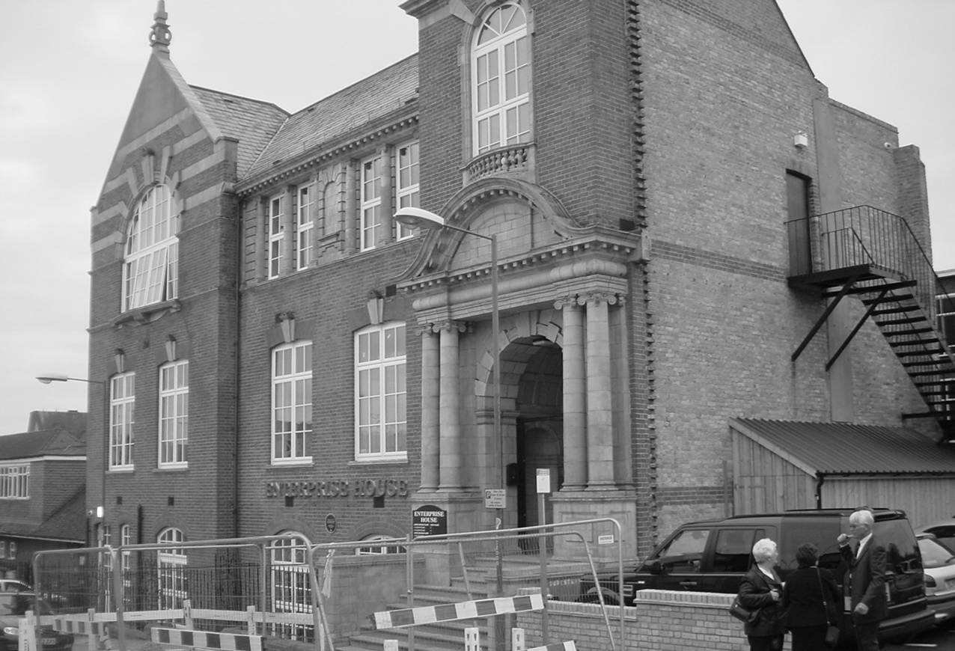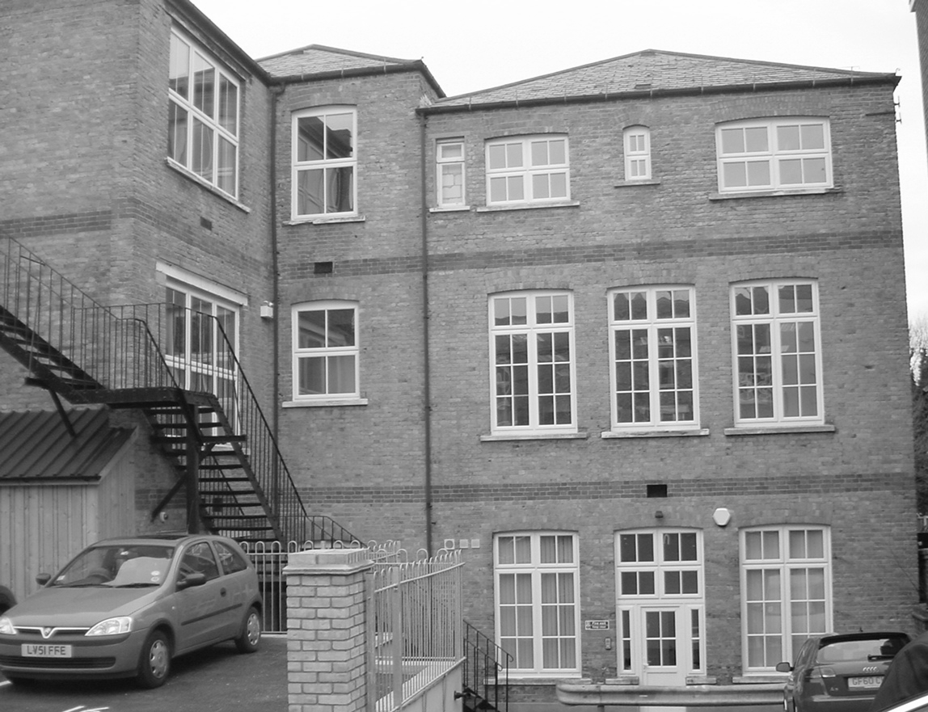

Front view Side View

