THE HISTORY OF WILMINGTON HALL
(Formerly known as ‘Common House’)

The origins of Wilmington Hall have been traced as far back as 1678. It is recorded that John Dynes, a Gentleman, owned 8 acres of land to the South of Wilmington Common. This land was later to become the site of Wilmington Boy’s Grammar School and part of the playing fields.

Edward Bathurst, (1680 – 1772) the son of William and Anne Bathurst, of Barn End Lane, was a London Barrister and Master of the Bench of the Middle Temple. In 1718 he inherited a house called Finchcocks from an Uncle. Then - following his marriage to a local heiress, Elizabeth Stringer he re-built the house at great expense, £30,000. It was finished in 1725. Edward later sold the house to his second son. His eldest was occupied with their estates in Jamaica.

Finchcocks House is still in existence today and is owned by Mr and Mrs Burnett.

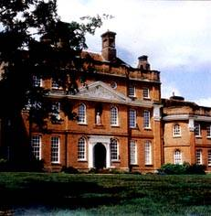

Finchcocks House Kent.

In 1734 Edward Bathurst built Common House, situated in Common Lane, Wilmington. He lived to the ripe old age of 92 and outlived all of his sons.

Edward subsequently sold Common House to Thomas Motley of Beckenham who bequeathed it to his daughter on her marriage to Mr Francis Austen, the son of Mr Francis Motley Austen of Sevenoaks.

In the early part of the nineteenth century the Austen family (distant relatives of Jane Austen) owned a large amount of land. They had bought it from the Bathhursts’. The Austen’s made considerable additions to the property and in 1837 they sold the entire estate.

George Russell bought part of this estate, about 35 acres, which included ‘Common House’. George Russell was Vicar’s Warden of St. Michael’s from 1845 to 1855. He died in 1856.

Details of the Russell family as taken from the 1841 census will give some idea of the grandeur of ‘Common House’ as it was still called then.

George Russell 47 Gentleman
Jane Russell 47 Wife
Jane Russell 20 Daughter
Mary Russell 18 Daughter
Emily Russell 10 Daughter
Fanny Russell 8 Daughter
Harriet Russell 6 Daughter

If there were any sons in the family they were obviously away from home on the night of the census.

Also resident in the house were;
James Russell 36 Gentleman
Jane Russell 36 Wife
Henrietta Russell 14 Daughter
Lydia Russell 6 mths Born in Ireland.
Harriet Penser 45 A lady of Independent Means

The live-in servants were;
William Pawley 21
Hugh Dougal 14
Eliza Atkins 24
Mary Atkins 22
Saphra (sic) Staples 23
Eliza Staples 23

None of these servants were born in Kent so one assumes they accompanied the family when they moved to Wilmington.

Another live-in servant was;
Mary O’Reargan 25 Born in Ireland.

George Russell died in 1856 and the House was taken over by William Cosier.

Two relevant entries have been found in the Richard Combe Miller diaries. The first records that the name of the building known as Common House has been changed to Wilmington Hall.

The second entry states that on “Friday Jan. 22nd 1875. Bessie and Stella drove in an open carriage in the afternoon and called on the Herveys’ at Wilmington Hall”.

This family could possibly be related to Lord Hervey who, at some stage, leased Darenth House.

In 1875 Mr Tasker laid gas mains to Wilmington Hall.

In 1889 Mr and Mrs Lloyd became the owners of the Hall.

Sir James Whitehead was born in Sedburgh, Yorkshire in 1834. He made his fortune in London and retired at the age of 47 years to live in Wilmington. In 1896 he purchased both Wilmington Hall and another building on the opposite side of Common Road known as Heathside. He changed the name of Heathside to Wilmington Manor and he assumed the title, ‘Lord of the Manor’. Boys had to touch their caps to him and girls had to curtsey.

Shortly after WWII Wilmington Manor was used by Dartford County Technical School for Girls in their first year. They completed the remainder of their curriculum in the school at Townley Road in Bexleyheath.

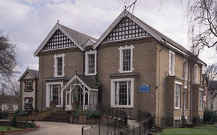

Wilmington Manor

Sir James lived in Wilmington Manor with his wife Lady Mercy Whitehead. Their son George Whitehead and his family lived in Wilmington Hall. George had two sons both of whom died during the First World War. He was succeeded by his brother, Sir Rowland John Rathbone Whitehead, 5th Baronet who lived at Highfield House, Kent and he continued the family line.

Sir James established a modern farm in the grounds of Wilmington Hall and he had a foot-bridge built over the road for the family to use when they visited each other.
(The bridge was still there when I was attending the school from 1950 -1953 and it survived until sometime in the 1970’s.)

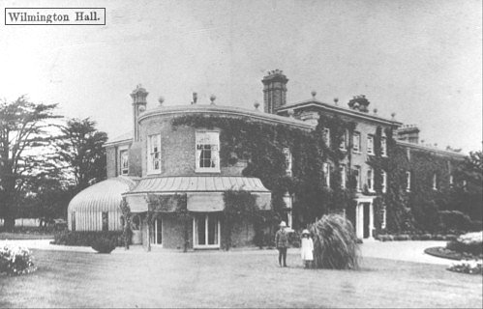

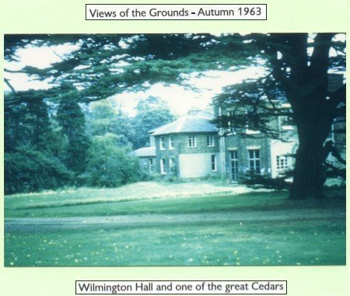

Sir James died in Wilmington in 1917 at 83 years of age. His title and Wilmington Hall passed to George Whitehead. Sir George and his family moved to Oxford in 1920.

Lord Dudley Gordon purchased Wilmington Hall in 1920 and remained the owner until 1950.

During the Second World War Wilmington Hall was used mainly as a drawing office by Vickers Engineering Company, and in 1950 it became Dartford Technical School for Boys. The Agricultural Section of the school used the surviving parts of the farm that had been established by Sir James.

The 1950 intake was the first to complete their full course at Wilmington Hall so it has always occupied a special place in my memory. The magnificent old building with sweeping staircases, open fireplaces with marble mantle shelves and a huge main door that added to its grandeur. None of us lowly pupils were allowed to use this entrance; it was ‘staff only’. We had to use what had probably been the servant’s entrance; we knew our place.

Mr Wall, the Headmaster, used to drive his beautiful Wolesley car up the driveway and park by the main door. One could perhaps imagine past owners being driven up this sweeping driveway in their horse drawn carriages. Mr Wall was the only person who drove to school in those days. I wonder how many pupils drive to school now? How times have changed!

In 1971 Wilmington Hall was demolished, supposedly to make way for extensions to the school to allow it to become a comprehensive school, which was never built. I always remember Wilmington Hall as a magnificent, historical old building and when I heard that it had been demolished I was aghast. In my mind this was an act of sheer vandalism. When it is remembered that the Hall was 228 years old and that Finchcocks House and Wilmington Manor are still in existence it makes the decision to demolish the Hall even worse. I wonder what happened to all those beautiful marble mantelshelves and stone blocks, or were they just dumped?

Without doubt the Hall may have required a lot of money to restore it to its former glory but beautiful old buildings such as this deserve better treatment. With the amount of land available on the site to build extensions to the school the Hall should have been retained for some other worthwhile use, such as a Library or maybe a Museum.

Edward Bathurst must have turned in his grave!

George Whitehead
1950 – 1953
PS. Unfortunately, for me, I am not a descendant of Sir James.
My Thanks to Iris Heddle for the help she gave me when I started this project.

